|  |  |
| --- | --- |
| lu135925on3bu_tmp_3360867a00ce4d37 | **Министерство науки и высшего образования Российской Федерации Федеральное государственное автономное образовательное учреждение высшего образования** **«Московский государственный технический университет имени Н.Э. Баумана** **(национальный исследовательский университет)» (МГТУ им. Н.Э. Баумана)** |

ФАКУЛЬТЕТ Информатика и системы управления и искусственный интеллект

КАФЕДРА                  Системы обработки информации и управления

**Домашнее задание №1**

**По курсу**

**«Оптимизация баз данных систем машинного обучения»**

**«Обнаружение функциональных зависимостей»**

**Вариант набора данных 19**

Подготовил:

Студент группы

**ИУ5-12М Пермяков Дмитрий Кириллович**

04.10.2025

Проверил:

**Плужникова Ольга Юрьевна**

*2025 г*.

**Задание**Для заданного набора данных

1) определите ключ с помощью алгоритма HyUCC;

2) сгенерируйте схему базы данных с таблицами в нормальной форме Бойса-Кодда с помощью алгоритма Normalize (автоматически сгенерированную схему БД можно увидеть в папке Metanome\results и в окне "Adding Context for backend");

3) представьте эту схему базы данных в нотации пакета ERwin;

4) преобразуйте схему базы данных в схему с синтетическими ключами;

5) предложите алгоритм заполнения таблиц базы данных (с синтетическими ключами) данными из вашего набора. Требования:

- записи набора данных читаются последовательно один раз,

- обращение к таблицам базы данных указывать в виде спецификаций операторов SQL.

|  |  |  |
| --- | --- | --- |
| Вариант набора данных | Имя файла (архив zip) | Имя  набора данных в архиве |
| **19** | 43 early+stage+diabetes+risk+prediction+dataset.zip | diabetes\_data\_upload.csv |

Это описание набора данных для предсказания риска диабета на ранних стадиях.

Age – возраст пациента (целое число).

Gender – пол (Male, Female).

Polyuria – учащённое мочеиспускание.

Polydipsia – чрезмерная жажда.

sudden weight loss – резкая потеря веса.

weakness – общая слабость.

Polyphagia – чрезмерный аппетит.

Genital thrush – грибковая инфекция половых органов.

visual blurring – нарушение зрения.

Itching – кожный зуд.

Irritability – раздражительность.

delayed healing – задержка заживления ран.

partial paresis – частичный паралич.

muscle stiffness – скованность мышц.

Alopecia – выпадение волос.

Obesity – ожирение.

Размер: 520 записей, 17 атрибутов

Цель: предсказание наличия диабета на ранних стадиях

Формат признаков:

1 числовой атрибут (Age)

15 категориальных атрибутов (ответы «Yes/No»)

1 целевая переменная (class: Positive или Negative)

Очистим дубликаты

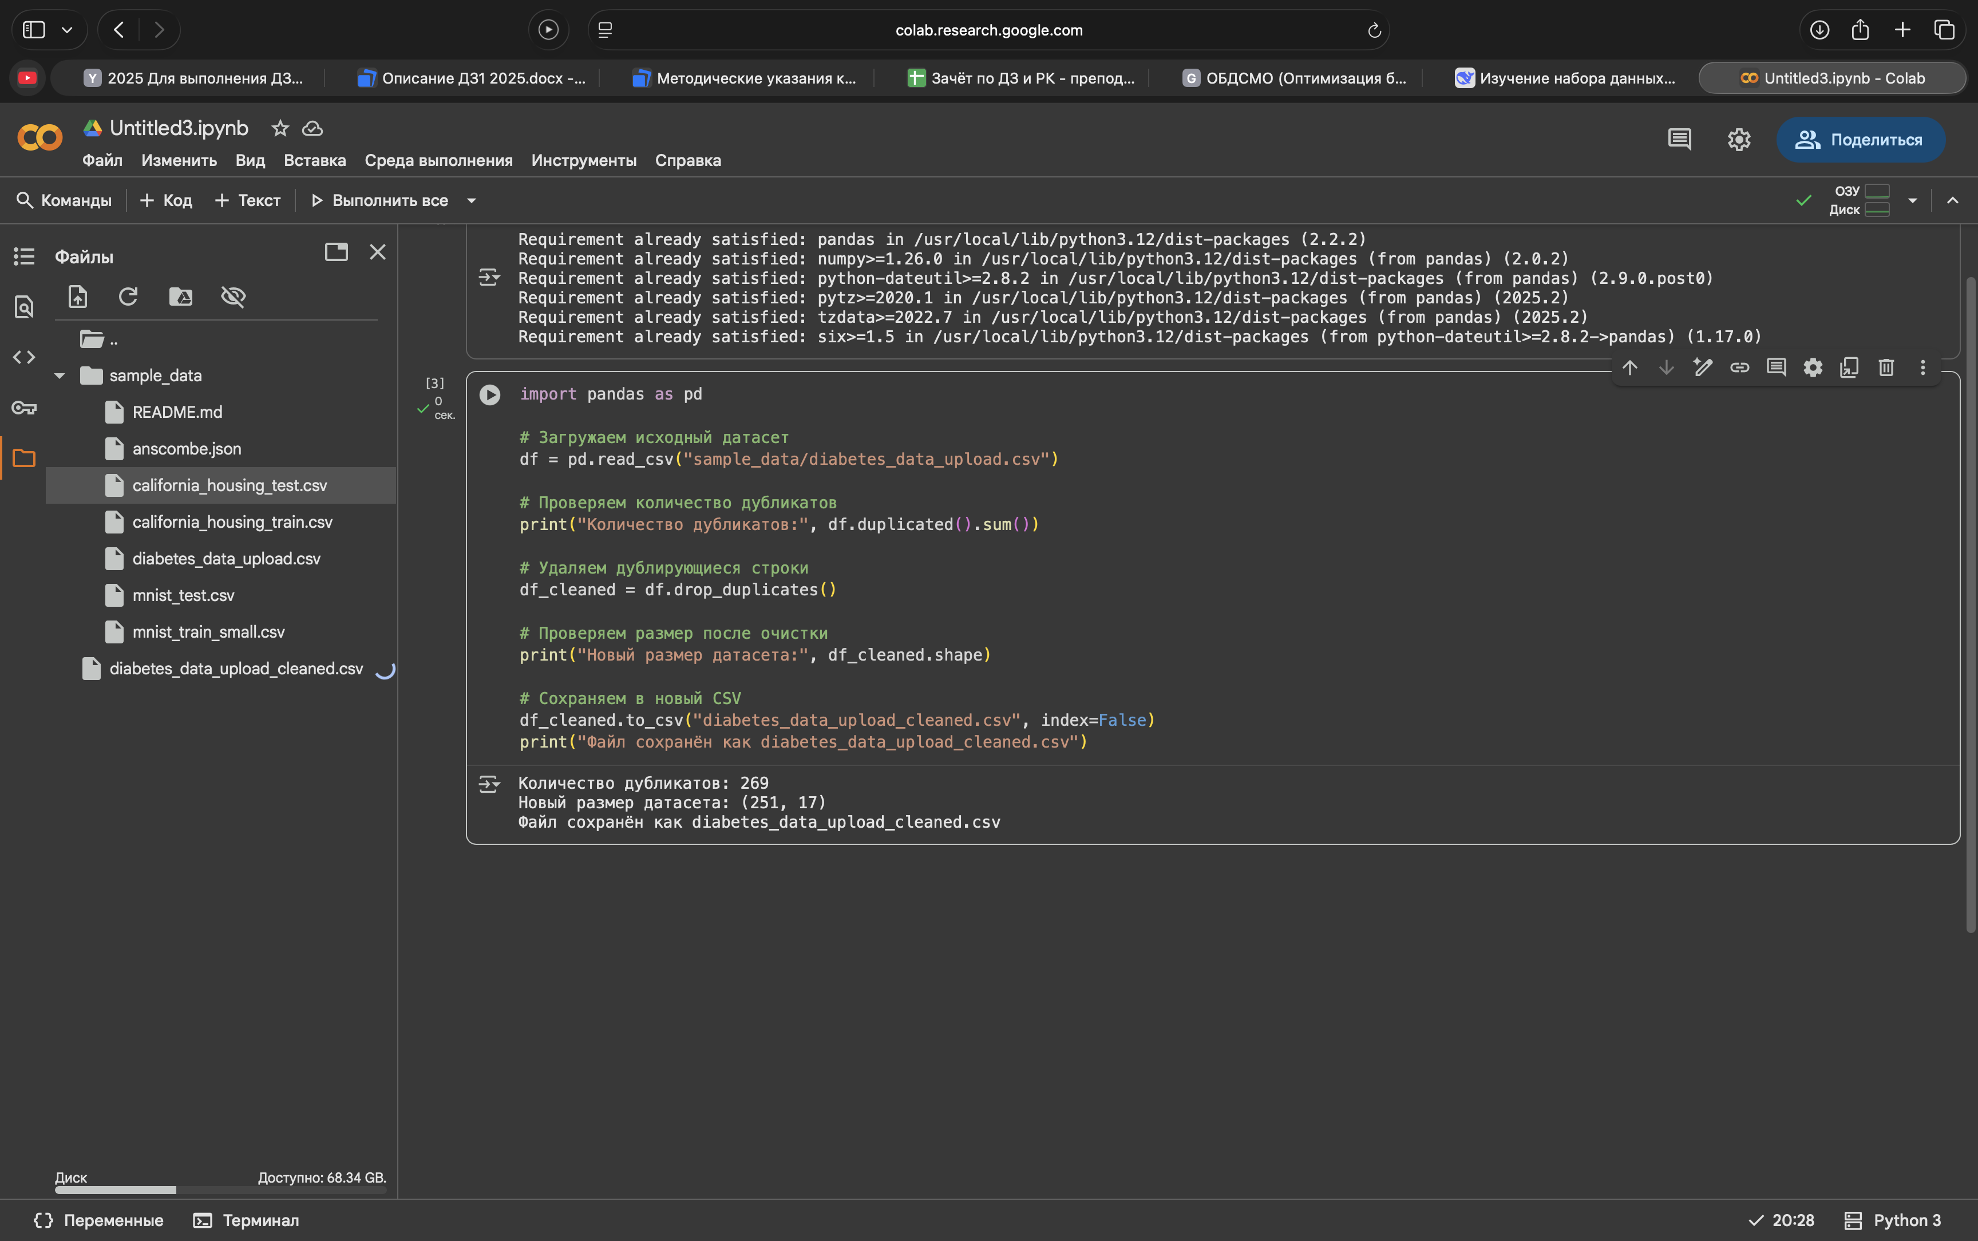

Добавим по пути Metanome\backend\WEB-INF\classes\inputData

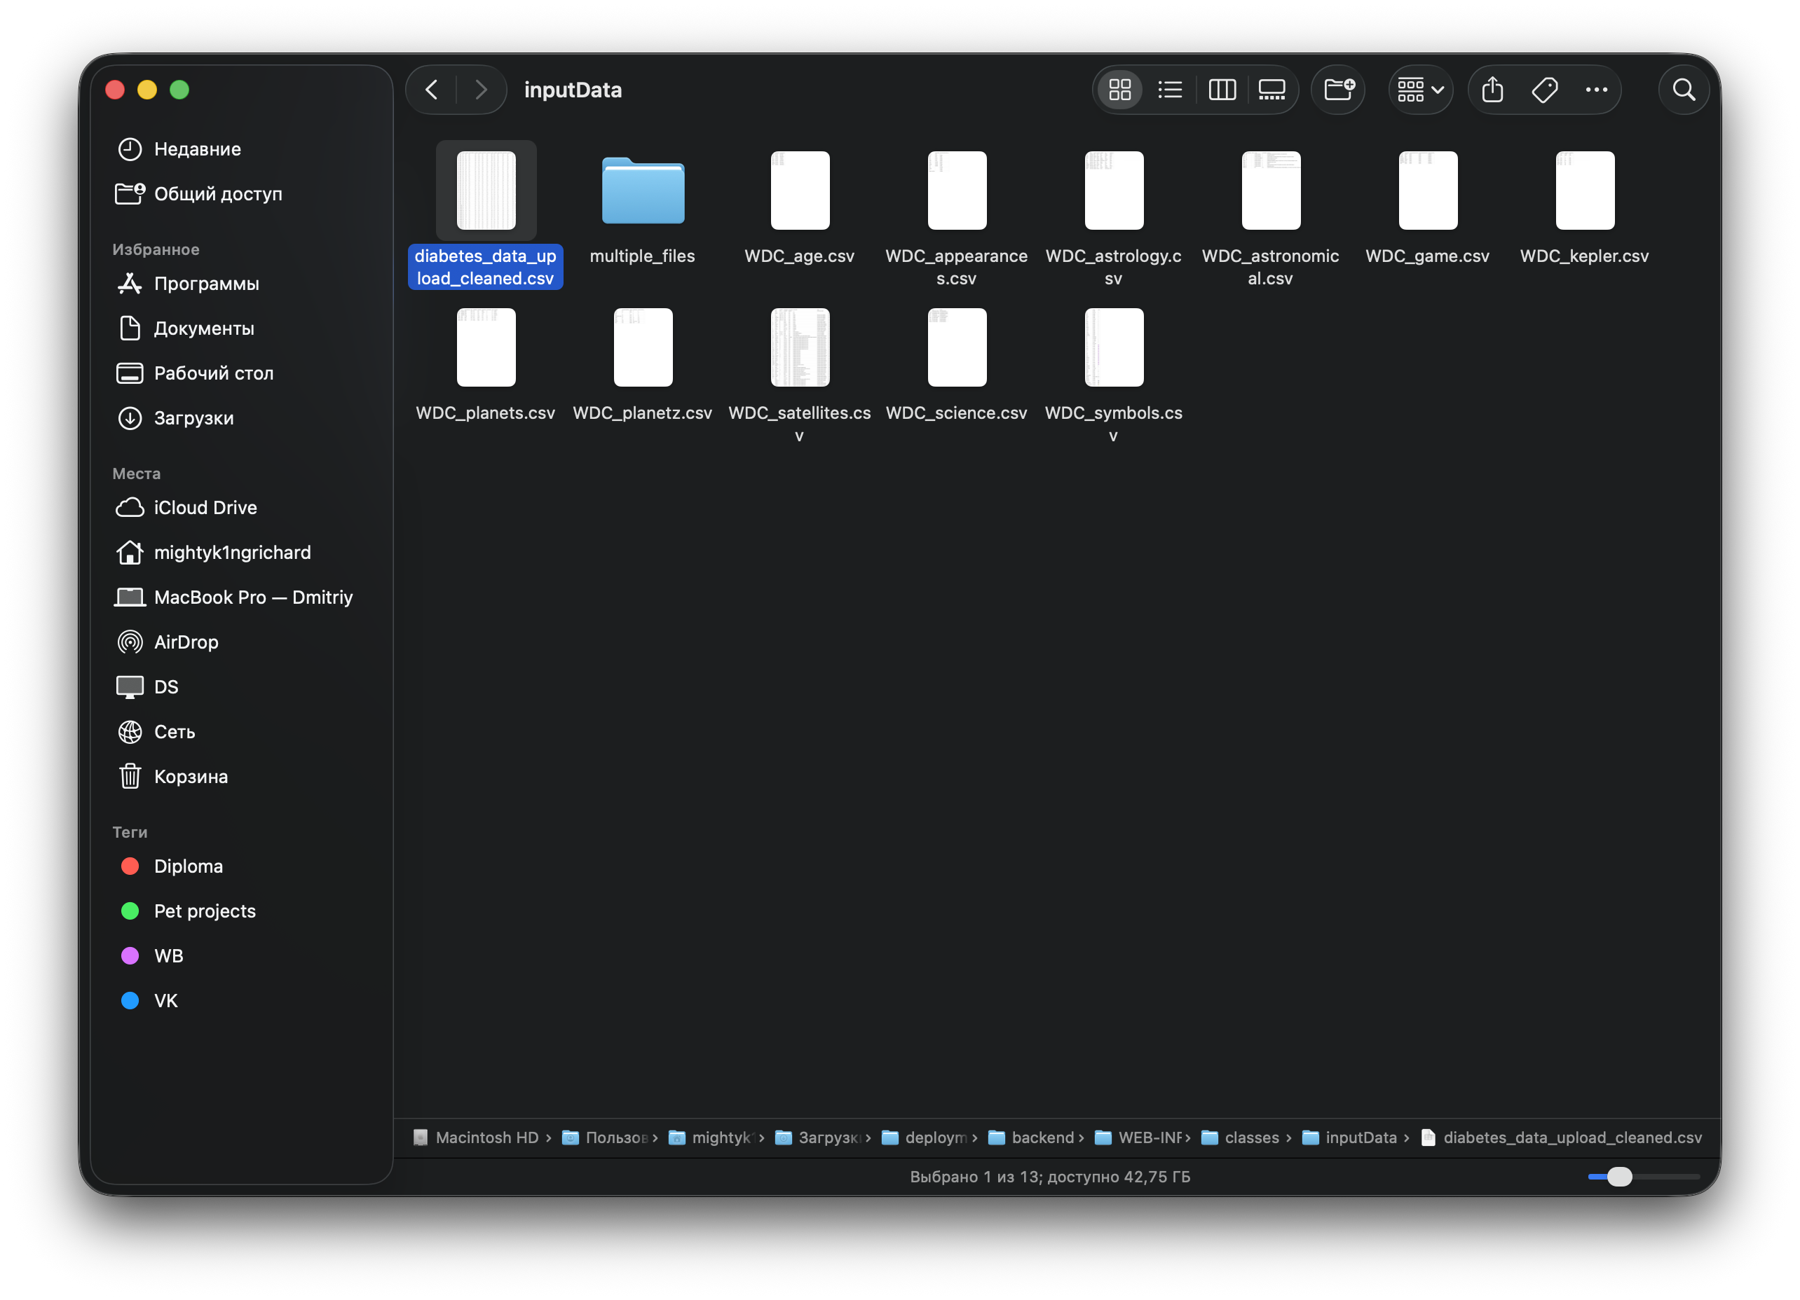

Добавил алгоритмы по пути Metanome\backend\WEB-INF\classes\algorithms

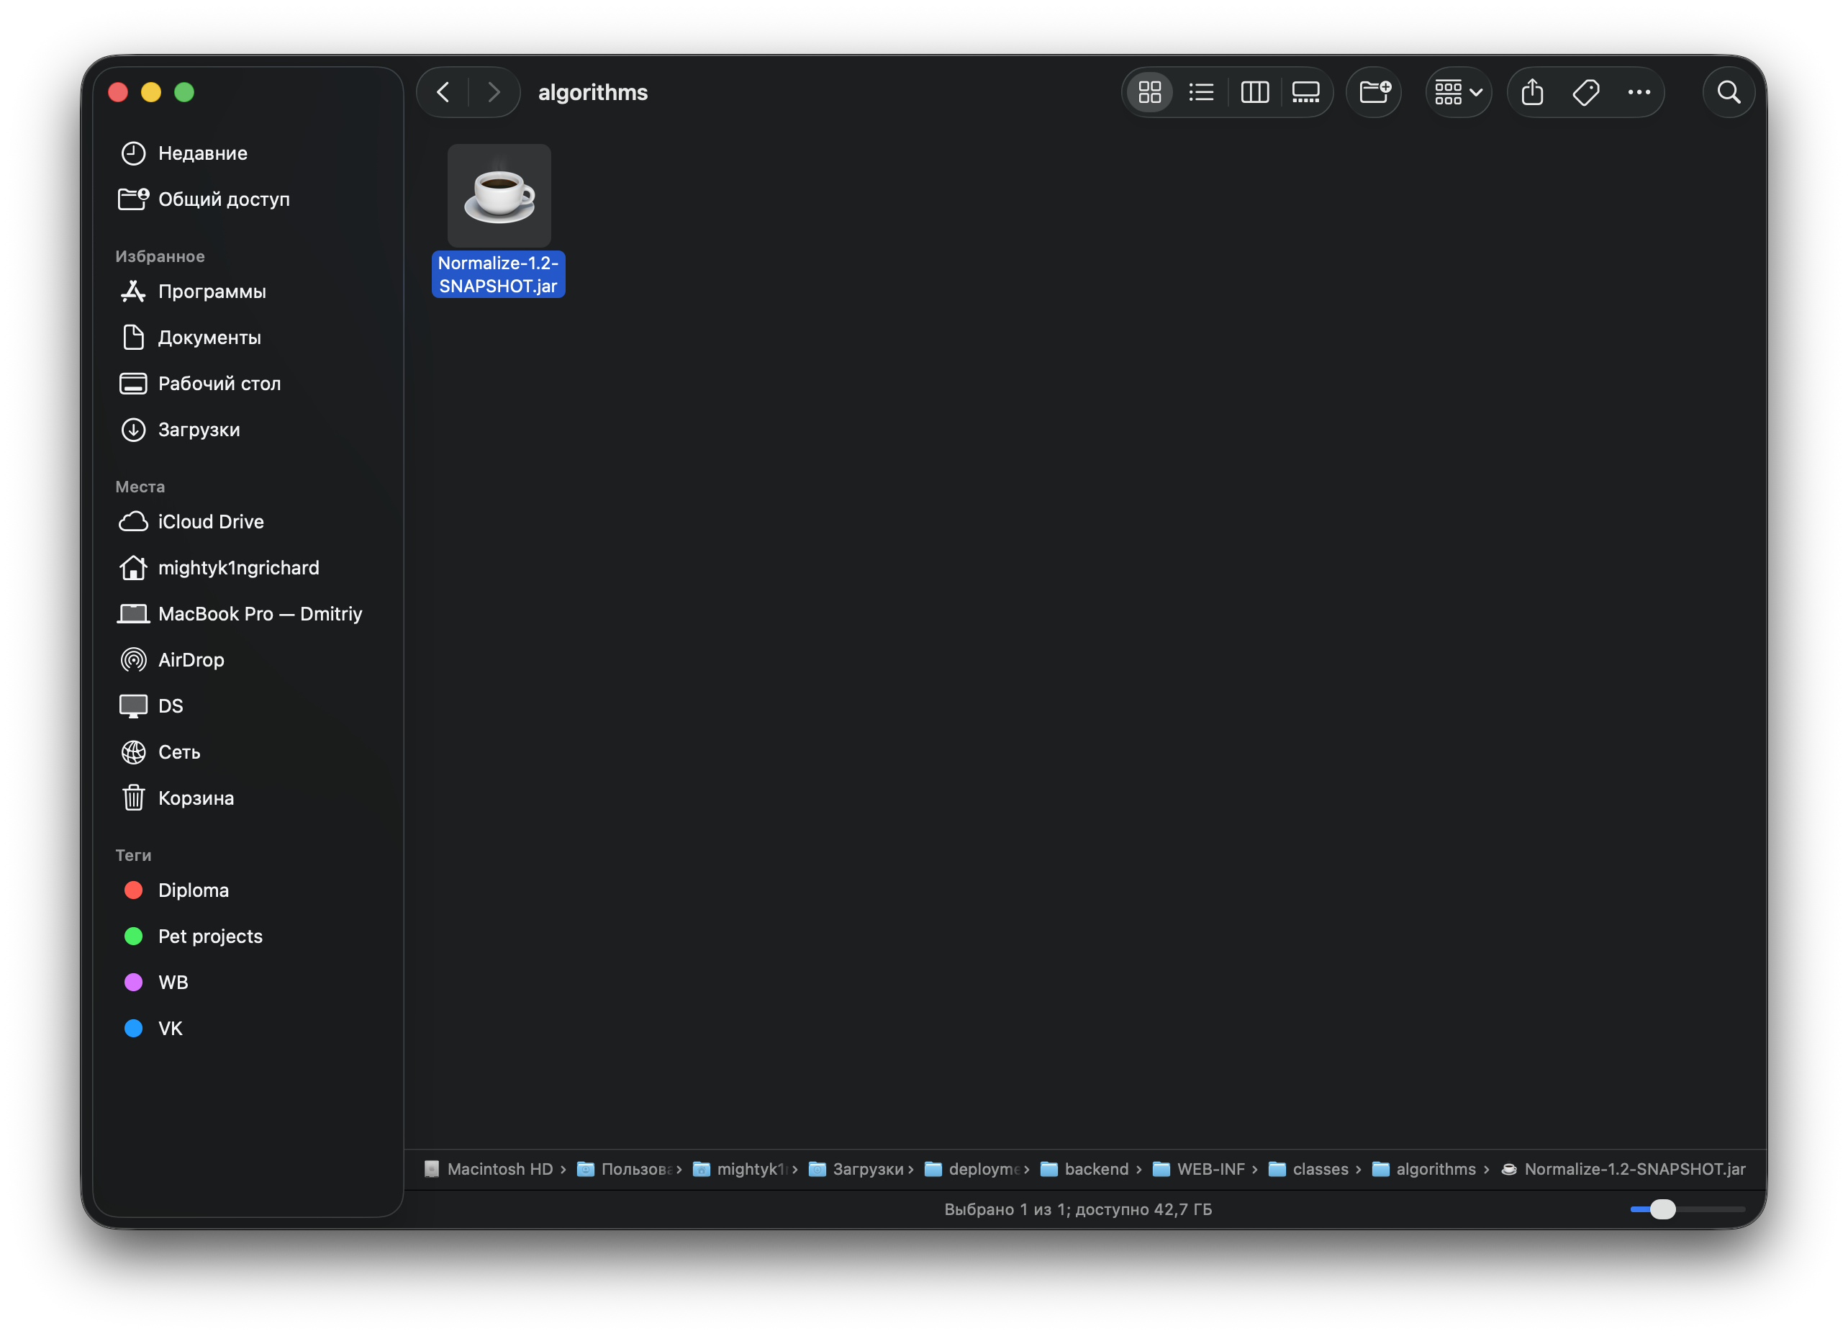

**Работа с Metanome.**

Запустил run.sh, открыл localhost:8080 в браузере.  
Изменил настройки датасета и алгоритмов.

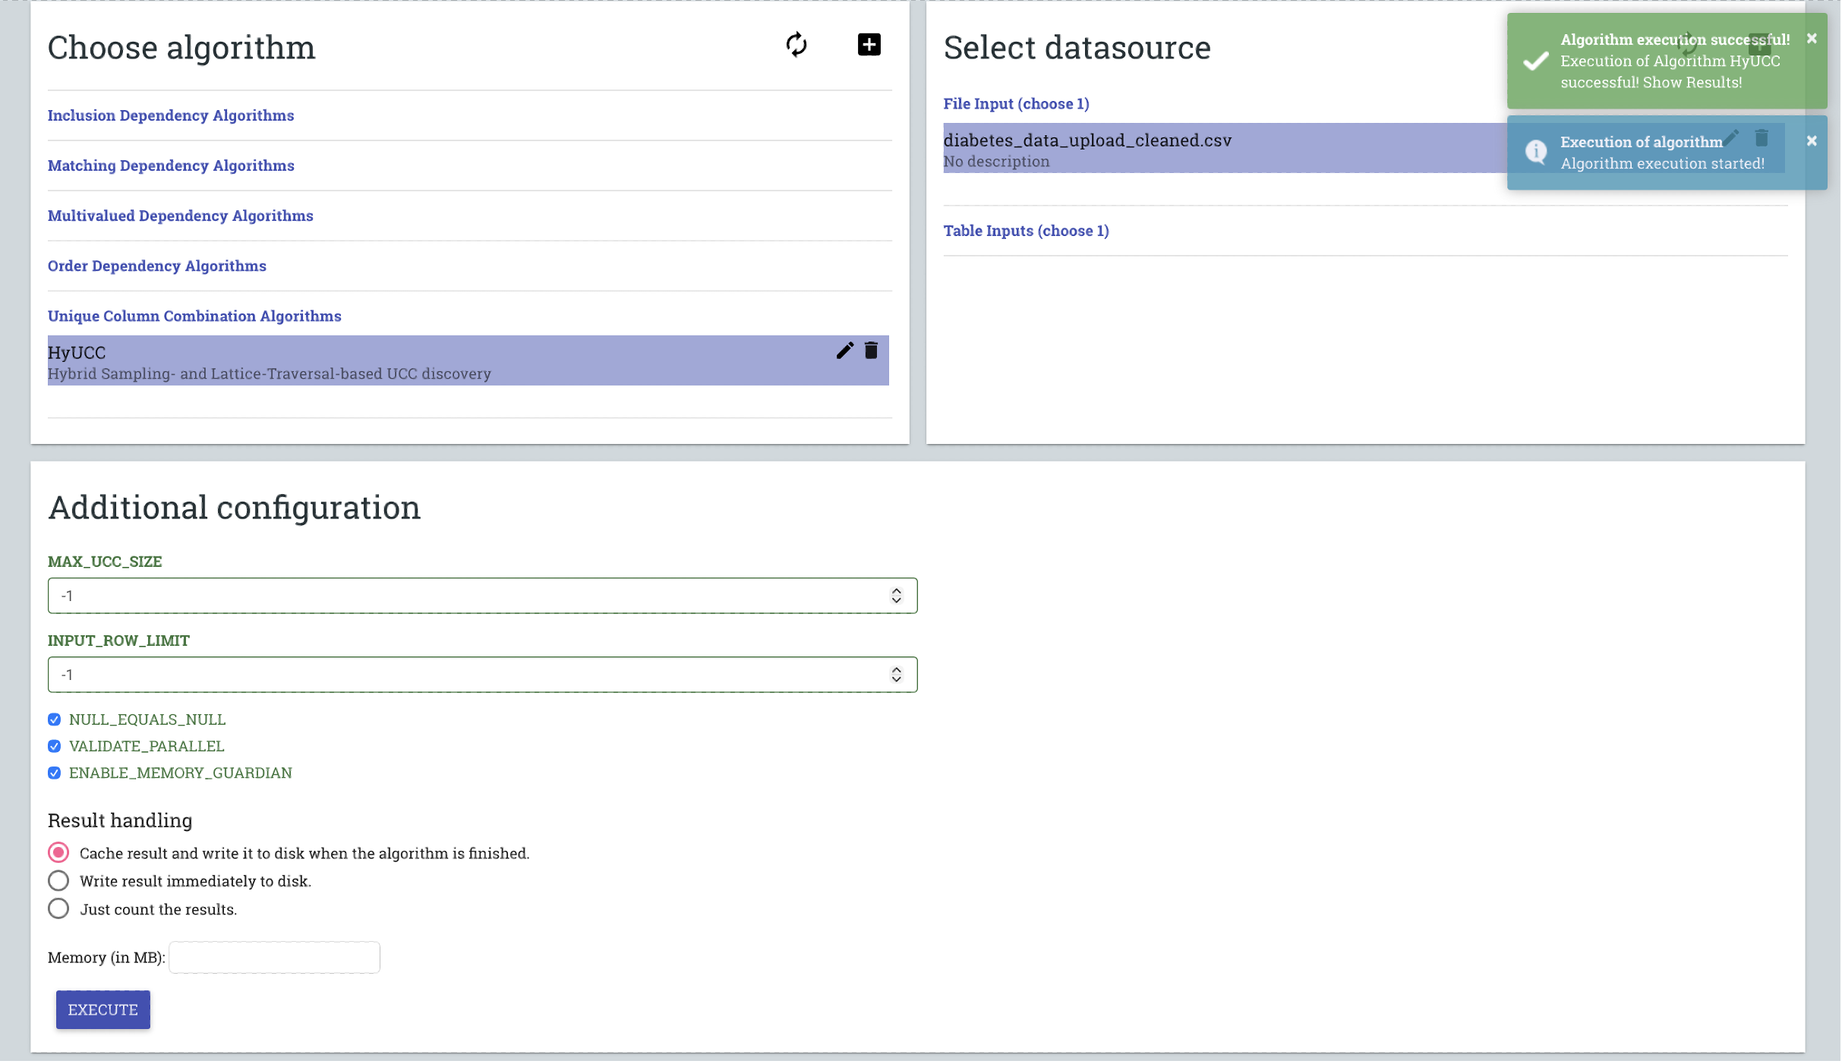

# TABLES

diabetes\_data\_upload\_cleaned.csv 1

# COLUMN

1.Polydipsia 4

1.Polyuria 3

1.partial paresis 13

1.Age 1

1.sudden weight loss 5

1.Obesity 16

1.Irritability 11

1.class 17

1.Genital thrush 8

1.Polyphagia 7

1.visual blurring 9

1.Alopecia 15

1.weakness 6

1.Itching 10

1.delayed healing 12

1.Gender 2

1.muscle stiffness 14

# RESULTS

1,15,2,10,16,7,3,12,5,9,6

1,15,2,10,16,4,7,12,13,5,9,6

1,15,2,8,10,16,7,12,13,5,9,6

1,15,2,10,16,7,17,12,13,5,9,6

Ключи:

1. {Age, Alopecia, Gender, Itching, Obesity, Polyphagia, Polyuria, delayed healing, sudden weight loss, visual blurring, weakness}
2. {Age, Alopecia, Gender, Itching, Obesity, Polydipsia, Polyphagia, delayed healing, partial paresis, sudden weight loss, visual blurring, weakness}
3. {Age, Alopecia, Gender, Genital thrush, Itching, Obesity, Polyphagia, delayed healing, partial paresis, sudden weight loss, visual blurring, weakness}
4. {Age, Alopecia, Gender, Itching, Obesity, Polyphagia, class, delayed healing, partial paresis, sudden weight loss, visual blurring, weakness}

Минимальные по мощности – комбинации из одиннадцати атрибутов (№ 1).

Далее Normalize

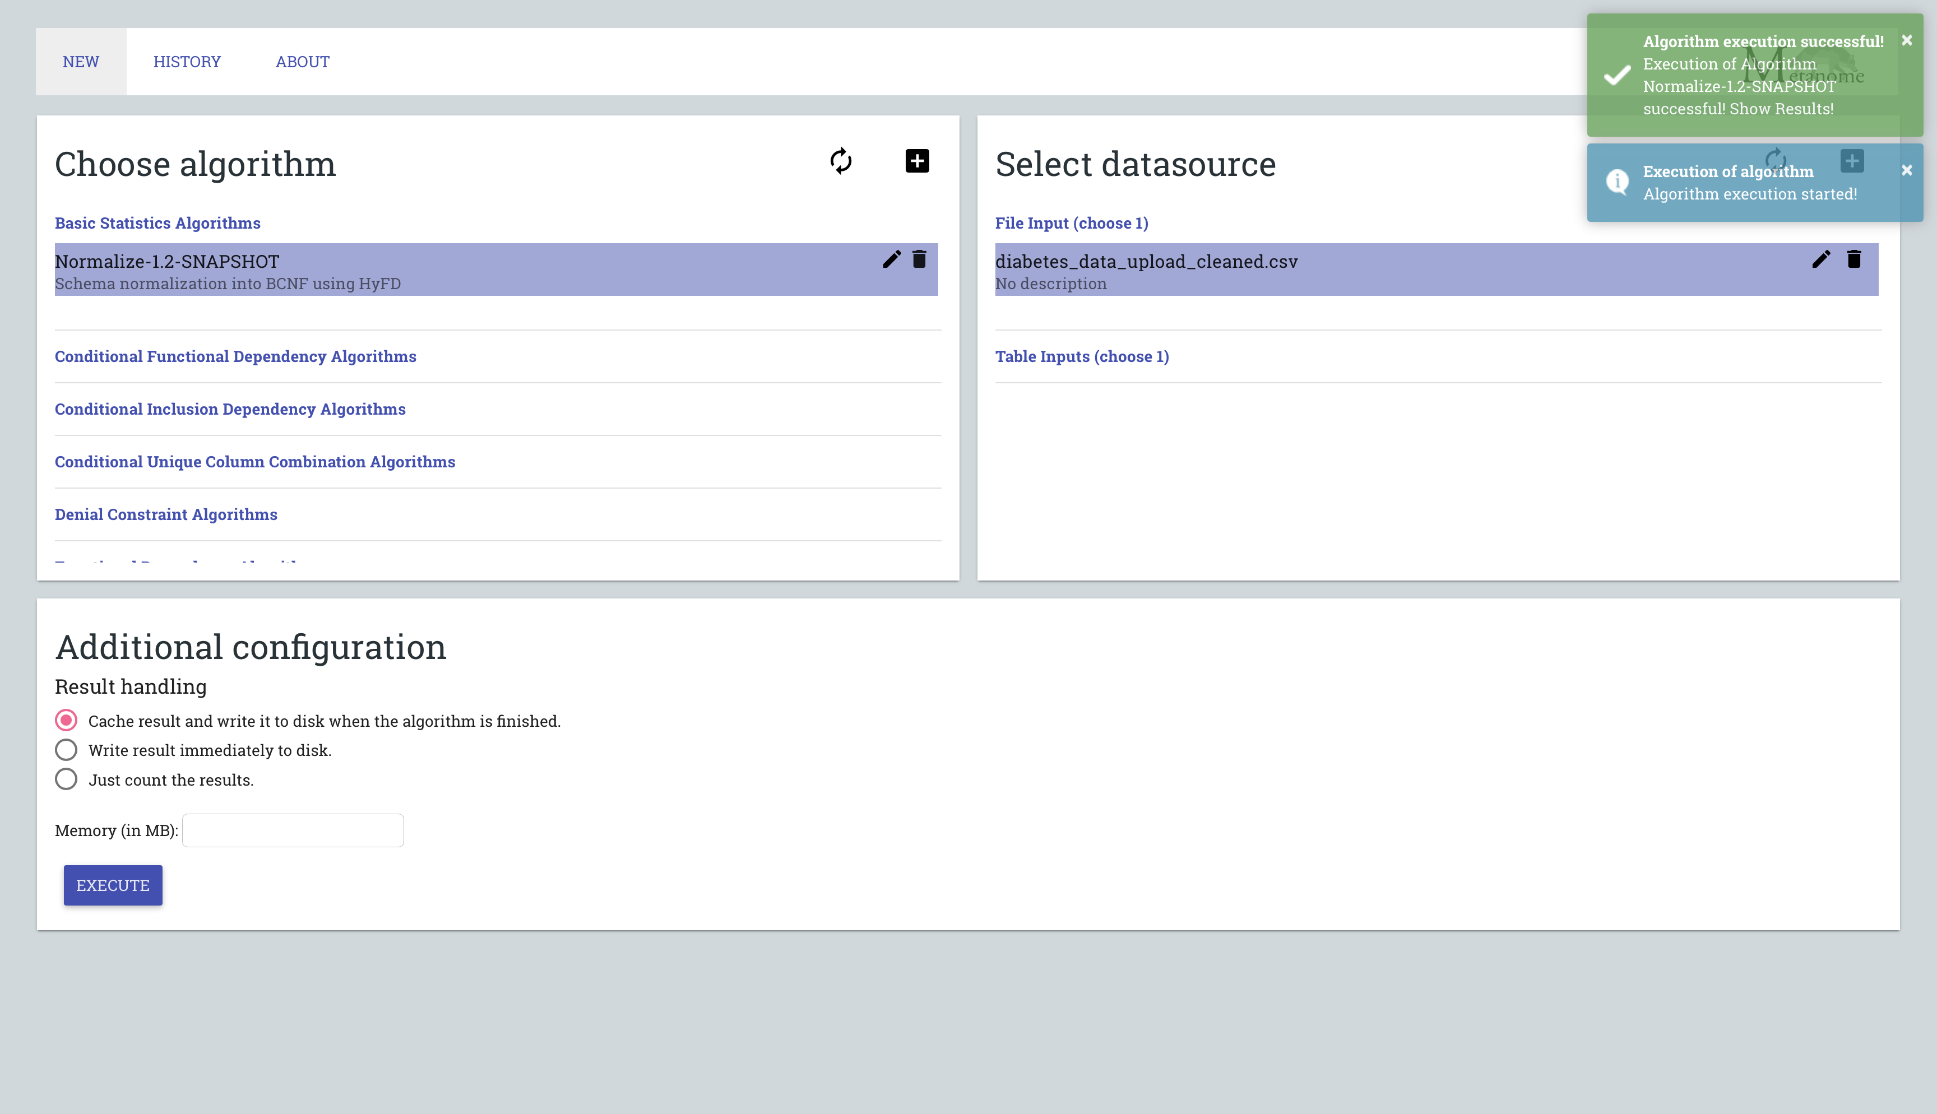

{"type":"BasicStatistic","columnCombination":{"columnIdentifiers":[{"tableIdentifier":"diabetes\_data\_upload\_cleaned.csv","columnIdentifier":"Age"},{"tableIdentifier":"diabetes\_data\_upload\_cleaned.csv","columnIdentifier":"Alopecia"},{"tableIdentifier":"diabetes\_data\_upload\_cleaned.csv","columnIdentifier":"Gender"},{"tableIdentifier":"diabetes\_data\_upload\_cleaned.csv","columnIdentifier":"Genital thrush"},{"tableIdentifier":"diabetes\_data\_upload\_cleaned.csv","columnIdentifier":"Itching"},{"tableIdentifier":"diabetes\_data\_upload\_cleaned.csv","columnIdentifier":"Obesity"},{"tableIdentifier":"diabetes\_data\_upload\_cleaned.csv","columnIdentifier":"Polyphagia"},{"tableIdentifier":"diabetes\_data\_upload\_cleaned.csv","columnIdentifier":"Polyuria"},{"tableIdentifier":"diabetes\_data\_upload\_cleaned.csv","columnIdentifier":"delayed healing"},{"tableIdentifier":"diabetes\_data\_upload\_cleaned.csv","columnIdentifier":"partial paresis"},{"tableIdentifier":"diabetes\_data\_upload\_cleaned.csv","columnIdentifier":"sudden weight loss"},{"tableIdentifier":"diabetes\_data\_upload\_cleaned.csv","columnIdentifier":"visual blurring"},{"tableIdentifier":"diabetes\_data\_upload\_cleaned.csv","columnIdentifier":"weakness"}]},"statisticMap":{"ForeignKey":{"type":"BasicStatisticValueString","value":"diabetes\_data\_upload\_cleaned.csv.Age, diabetes\_data\_upload\_cleaned.csv.Polyuria, diabetes\_data\_upload\_cleaned.csv.sudden weight loss, diabetes\_data\_upload\_cleaned.csv.weakness, diabetes\_data\_upload\_cleaned.csv.visual blurring, diabetes\_data\_upload\_cleaned.csv.Itching, diabetes\_data\_upload\_cleaned.csv.delayed healing, diabetes\_data\_upload\_cleaned.csv.partial paresis, diabetes\_data\_upload\_cleaned.csv.Alopecia"},"PrimaryKey":{"type":"BasicStatisticValueString","value":"diabetes\_data\_upload\_cleaned.csv.Age, diabetes\_data\_upload\_cleaned.csv.Gender, diabetes\_data\_upload\_cleaned.csv.Polyuria, diabetes\_data\_upload\_cleaned.csv.sudden weight loss, diabetes\_data\_upload\_cleaned.csv.weakness, diabetes\_data\_upload\_cleaned.csv.Polyphagia, diabetes\_data\_upload\_cleaned.csv.Genital thrush, diabetes\_data\_upload\_cleaned.csv.visual blurring, diabetes\_data\_upload\_cleaned.csv.Itching, diabetes\_data\_upload\_cleaned.csv.delayed healing, diabetes\_data\_upload\_cleaned.csv.Alopecia, diabetes\_data\_upload\_cleaned.csv.Obesity"}}}

{"type":"BasicStatistic","columnCombination":{"columnIdentifiers":[{"tableIdentifier":"diabetes\_data\_upload\_cleaned.csv","columnIdentifier":"Age"},{"tableIdentifier":"diabetes\_data\_upload\_cleaned.csv","columnIdentifier":"Alopecia"},{"tableIdentifier":"diabetes\_data\_upload\_cleaned.csv","columnIdentifier":"Irritability"},{"tableIdentifier":"diabetes\_data\_upload\_cleaned.csv","columnIdentifier":"Itching"},{"tableIdentifier":"diabetes\_data\_upload\_cleaned.csv","columnIdentifier":"Polyuria"},{"tableIdentifier":"diabetes\_data\_upload\_cleaned.csv","columnIdentifier":"delayed healing"},{"tableIdentifier":"diabetes\_data\_upload\_cleaned.csv","columnIdentifier":"partial paresis"},{"tableIdentifier":"diabetes\_data\_upload\_cleaned.csv","columnIdentifier":"sudden weight loss"},{"tableIdentifier":"diabetes\_data\_upload\_cleaned.csv","columnIdentifier":"visual blurring"},{"tableIdentifier":"diabetes\_data\_upload\_cleaned.csv","columnIdentifier":"weakness"}]},"statisticMap":{"PrimaryKey":{"type":"BasicStatisticValueString","value":"diabetes\_data\_upload\_cleaned.csv.Age, diabetes\_data\_upload\_cleaned.csv.Polyuria, diabetes\_data\_upload\_cleaned.csv.sudden weight loss, diabetes\_data\_upload\_cleaned.csv.weakness, diabetes\_data\_upload\_cleaned.csv.visual blurring, diabetes\_data\_upload\_cleaned.csv.Itching, diabetes\_data\_upload\_cleaned.csv.delayed healing, diabetes\_data\_upload\_cleaned.csv.partial paresis, diabetes\_data\_upload\_cleaned.csv.Alopecia"}}}

{"type":"BasicStatistic","columnCombination":{"columnIdentifiers":[{"tableIdentifier":"diabetes\_data\_upload\_cleaned.csv","columnIdentifier":"Age"},{"tableIdentifier":"diabetes\_data\_upload\_cleaned.csv","columnIdentifier":"Gender"},{"tableIdentifier":"diabetes\_data\_upload\_cleaned.csv","columnIdentifier":"Genital thrush"},{"tableIdentifier":"diabetes\_data\_upload\_cleaned.csv","columnIdentifier":"Itching"},{"tableIdentifier":"diabetes\_data\_upload\_cleaned.csv","columnIdentifier":"Polydipsia"},{"tableIdentifier":"diabetes\_data\_upload\_cleaned.csv","columnIdentifier":"Polyphagia"},{"tableIdentifier":"diabetes\_data\_upload\_cleaned.csv","columnIdentifier":"Polyuria"},{"tableIdentifier":"diabetes\_data\_upload\_cleaned.csv","columnIdentifier":"sudden weight loss"},{"tableIdentifier":"diabetes\_data\_upload\_cleaned.csv","columnIdentifier":"visual blurring"},{"tableIdentifier":"diabetes\_data\_upload\_cleaned.csv","columnIdentifier":"weakness"}]},"statisticMap":{"ForeignKey":{"type":"BasicStatisticValueString","value":"diabetes\_data\_upload\_cleaned.csv.Age, diabetes\_data\_upload\_cleaned.csv.Gender, diabetes\_data\_upload\_cleaned.csv.Polyuria, diabetes\_data\_upload\_cleaned.csv.Polydipsia, diabetes\_data\_upload\_cleaned.csv.sudden weight loss, diabetes\_data\_upload\_cleaned.csv.weakness, diabetes\_data\_upload\_cleaned.csv.Polyphagia, diabetes\_data\_upload\_cleaned.csv.Genital thrush, diabetes\_data\_upload\_cleaned.csv.visual blurring"},"PrimaryKey":{"type":"BasicStatisticValueString","value":"diabetes\_data\_upload\_cleaned.csv.Age, diabetes\_data\_upload\_cleaned.csv.Gender, diabetes\_data\_upload\_cleaned.csv.Polyuria, diabetes\_data\_upload\_cleaned.csv.sudden weight loss, diabetes\_data\_upload\_cleaned.csv.weakness, diabetes\_data\_upload\_cleaned.csv.Polyphagia, diabetes\_data\_upload\_cleaned.csv.Genital thrush, diabetes\_data\_upload\_cleaned.csv.visual blurring, diabetes\_data\_upload\_cleaned.csv.Itching"}}}

{"type":"BasicStatistic","columnCombination":{"columnIdentifiers":[{"tableIdentifier":"diabetes\_data\_upload\_cleaned.csv","columnIdentifier":"Age"},{"tableIdentifier":"diabetes\_data\_upload\_cleaned.csv","columnIdentifier":"Gender"},{"tableIdentifier":"diabetes\_data\_upload\_cleaned.csv","columnIdentifier":"Genital thrush"},{"tableIdentifier":"diabetes\_data\_upload\_cleaned.csv","columnIdentifier":"Polydipsia"},{"tableIdentifier":"diabetes\_data\_upload\_cleaned.csv","columnIdentifier":"Polyphagia"},{"tableIdentifier":"diabetes\_data\_upload\_cleaned.csv","columnIdentifier":"Polyuria"},{"tableIdentifier":"diabetes\_data\_upload\_cleaned.csv","columnIdentifier":"muscle stiffness"},{"tableIdentifier":"diabetes\_data\_upload\_cleaned.csv","columnIdentifier":"sudden weight loss"},{"tableIdentifier":"diabetes\_data\_upload\_cleaned.csv","columnIdentifier":"visual blurring"},{"tableIdentifier":"diabetes\_data\_upload\_cleaned.csv","columnIdentifier":"weakness"}]},"statisticMap":{"ForeignKey":{"type":"BasicStatisticValueString","value":"diabetes\_data\_upload\_cleaned.csv.Age, diabetes\_data\_upload\_cleaned.csv.Gender, diabetes\_data\_upload\_cleaned.csv.Polydipsia, diabetes\_data\_upload\_cleaned.csv.sudden weight loss, diabetes\_data\_upload\_cleaned.csv.weakness, diabetes\_data\_upload\_cleaned.csv.Polyphagia, diabetes\_data\_upload\_cleaned.csv.Genital thrush, diabetes\_data\_upload\_cleaned.csv.visual blurring"},"PrimaryKey":{"type":"BasicStatisticValueString","value":"diabetes\_data\_upload\_cleaned.csv.Age, diabetes\_data\_upload\_cleaned.csv.Gender, diabetes\_data\_upload\_cleaned.csv.Polyuria, diabetes\_data\_upload\_cleaned.csv.Polydipsia, diabetes\_data\_upload\_cleaned.csv.sudden weight loss, diabetes\_data\_upload\_cleaned.csv.weakness, diabetes\_data\_upload\_cleaned.csv.Polyphagia, diabetes\_data\_upload\_cleaned.csv.Genital thrush, diabetes\_data\_upload\_cleaned.csv.visual blurring"}}}

{"type":"BasicStatistic","columnCombination":{"columnIdentifiers":[{"tableIdentifier":"diabetes\_data\_upload\_cleaned.csv","columnIdentifier":"Age"},{"tableIdentifier":"diabetes\_data\_upload\_cleaned.csv","columnIdentifier":"Gender"},{"tableIdentifier":"diabetes\_data\_upload\_cleaned.csv","columnIdentifier":"Genital thrush"},{"tableIdentifier":"diabetes\_data\_upload\_cleaned.csv","columnIdentifier":"Polydipsia"},{"tableIdentifier":"diabetes\_data\_upload\_cleaned.csv","columnIdentifier":"Polyphagia"},{"tableIdentifier":"diabetes\_data\_upload\_cleaned.csv","columnIdentifier":"class"},{"tableIdentifier":"diabetes\_data\_upload\_cleaned.csv","columnIdentifier":"sudden weight loss"},{"tableIdentifier":"diabetes\_data\_upload\_cleaned.csv","columnIdentifier":"visual blurring"},{"tableIdentifier":"diabetes\_data\_upload\_cleaned.csv","columnIdentifier":"weakness"}]},"statisticMap":{"PrimaryKey":{"type":"BasicStatisticValueString","value":"diabetes\_data\_upload\_cleaned.csv.Age, diabetes\_data\_upload\_cleaned.csv.Gender, diabetes\_data\_upload\_cleaned.csv.Polydipsia, diabetes\_data\_upload\_cleaned.csv.sudden weight loss, diabetes\_data\_upload\_cleaned.csv.weakness, diabetes\_data\_upload\_cleaned.csv.Polyphagia, diabetes\_data\_upload\_cleaned.csv.Genital thrush, diabetes\_data\_upload\_cleaned.csv.visual blurring"}}}

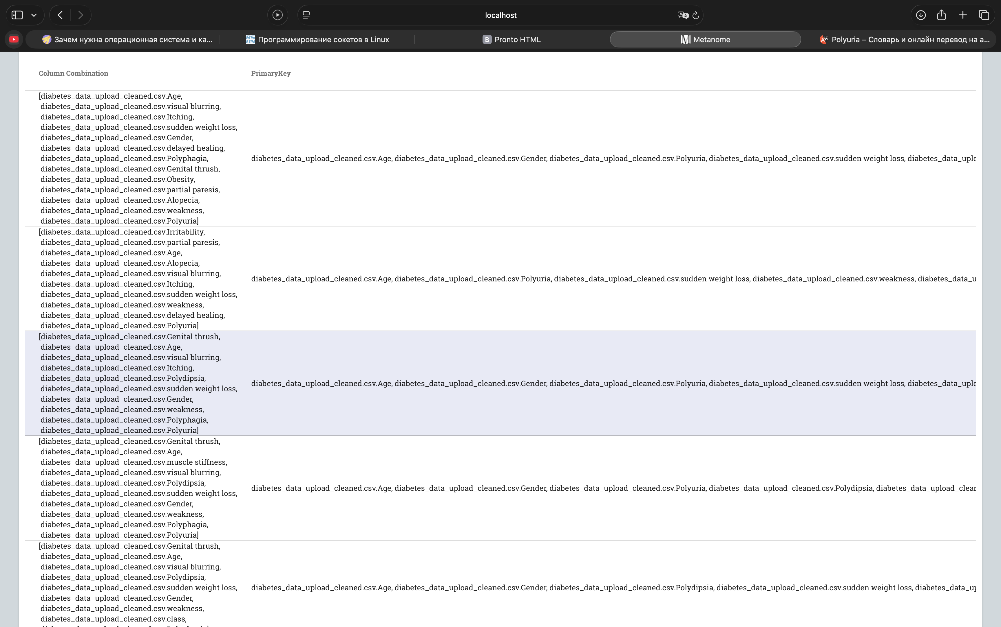

Запись в консоли

Decomposition is complete. We now need to find good primary keys for relations without a primary key.

[AGE, GENDER, POLYURIA, SUDDEN WEIGHT LOSS, WEAKNESS, POLYPHAGIA, GENITAL THRUSH, VISUAL BLURRING, ITCHING, DELAYED HEALING, partial paresis, ALOPECIA, OBESITY]

[AGE, POLYURIA, SUDDEN WEIGHT LOSS, WEAKNESS, VISUAL BLURRING, ITCHING, Irritability, DELAYED HEALING, PARTIAL PARESIS, ALOPECIA]

[AGE, GENDER, POLYURIA, Polydipsia, SUDDEN WEIGHT LOSS, WEAKNESS, POLYPHAGIA, GENITAL THRUSH, VISUAL BLURRING, ITCHING]

[AGE, GENDER, POLYURIA, POLYDIPSIA, SUDDEN WEIGHT LOSS, WEAKNESS, POLYPHAGIA, GENITAL THRUSH, VISUAL BLURRING, muscle stiffness]

[AGE, GENDER, POLYDIPSIA, SUDDEN WEIGHT LOSS, WEAKNESS, POLYPHAGIA, GENITAL THRUSH, VISUAL BLURRING, class]

В процессе нормализации было выявлено **5 отношений (таблиц)** с различными комбинациями атрибутов. Это говорит о том, что система нашла функциональные зависимости и выполнила декомпозицию исходных данные

Ключи:

1. {Age, Alopecia, Gender, Itching, Obesity, Polyphagia, Polyuria, delayed healing, sudden weight loss, visual blurring, weakness}
2. {Age, Alopecia, Gender, Itching, Obesity, Polydipsia, Polyphagia, delayed healing, partial paresis, sudden weight loss, visual blurring, weakness}
3. {Age, Alopecia, Gender, Genital thrush, Itching, Obesity, Polyphagia, delayed healing, partial paresis, sudden weight loss, visual blurring, weakness}
4. {Age, Alopecia, Gender, Itching, Obesity, Polyphagia, class, delayed healing, partial paresis, sudden weight loss, visual blurring, weakness}

[AGE, GENDER, POLYURIA, SUDDEN WEIGHT LOSS, WEAKNESS, POLYPHAGIA, GENITAL THRUSH, VISUAL BLURRING, ITCHING, DELAYED HEALING, partial paresis, ALOPECIA, OBESITY]

[AGE, POLYURIA, SUDDEN WEIGHT LOSS, WEAKNESS, VISUAL BLURRING, ITCHING, Irritability, DELAYED HEALING, PARTIAL PARESIS, ALOPECIA]

[AGE, GENDER, POLYURIA, Polydipsia, SUDDEN WEIGHT LOSS, WEAKNESS, POLYPHAGIA, GENITAL THRUSH, VISUAL BLURRING, ITCHING]

[AGE, GENDER, POLYURIA, POLYDIPSIA, SUDDEN WEIGHT LOSS, WEAKNESS, POLYPHAGIA, GENITAL THRUSH, VISUAL BLURRING, muscle stiffness]

[AGE, GENDER, POLYDIPSIA, SUDDEN WEIGHT LOSS, WEAKNESS, POLYPHAGIA, GENITAL THRUSH, VISUAL BLURRING, class]

**Схема ERWin:**

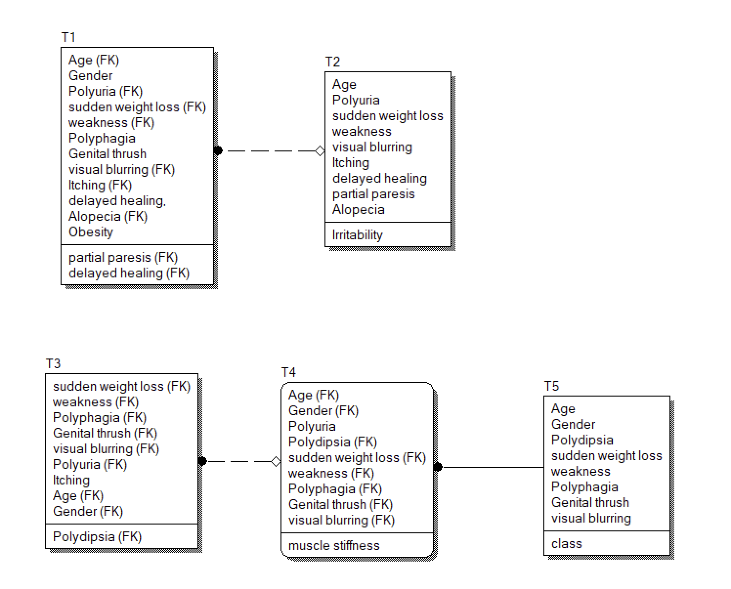

**Схема с синтетическим ключом В БД создавалась бы так:**

**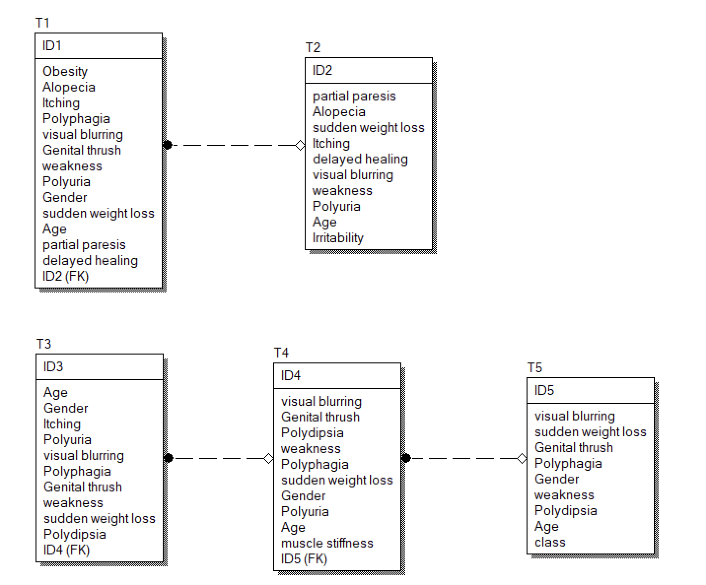**

**Алгоритм заполнения таблиц базы данных данными из набора**

Опеределим порядок заполнения таблиц: T2, T1, T5, T4, T3

Получаем на вход строку из датасета:

{Age, Gender, Polyuria, Polydipsia, sudden\_weight\_loss, weakness, Polyphagia, Genital\_thrush, visual blurring, Itching, Irritability, delayed\_healing, partial\_paresis, muscle\_stiffness, Alopecia, Obesity, class}

1. T2

{

SELECT id FROM T2 WHERE T2.partial\_paresis = partial\_paresis AND T2.Alopecia = Alopecia AND T2.sudden\_weight\_loss = sudden\_weight\_loss AND T2.Itching = Itching AND T2.delayed\_healing = delayed\_healing AND T2.visual\_blurring = visual\_blurring AND T2.weakness = weakness AND T2.Polyuria = Polyuria AND T2.Age = Age AND T2.Irritability = Irritability

Результаты запишем в **t2\_id**.

Если t2\_id == NULL, то:

INSERT INTO T2 (partial\_paresis, Alopecia, sudden\_weight\_loss, Itching, delayed\_healing, visual\_blurring, weakness, Polyuria, Age, Irritability)   
VALUES (partial\_paresis, Alopecia, sudden\_weight\_loss, Itching, delayed\_healing, visual\_blurring, weakness, Polyuria, Age, Irritability);

Переход к следующей таблице;

Иначе:

Переход к следующей таблице;

}

1. T1

{

SELECT T1.Obesity = Obesity AND T1.Alopecia = Alopecia AND T1.delayed\_healing = delayed\_healing AND T1.Itching = Itching AND T1.Polyphagia = Polyphagia AND T1.visual\_blurring = visual\_blurring AND T1.Genital\_thrush = Genital\_thrush AND T1.weakness = weakness AND T1.Polyuria = Polyuria AND T1.Gender = Gender AND T1.sudden\_weight\_loss = sudden\_weight\_loss AND T1.Age = Age AND T1.partial\_paresis = partial\_paresis AND T1.ID2 = **t2\_id**  
FROM T1;

Если результат запроса NULL, то:

INSERT INTO T1 (Obesity, Alopecia, delayed\_healing, Itching, Polyphagia, visual\_blurring, Genital\_thrush, weakness, Polyuria, Gender, sudden\_weight\_loss, Age, partial\_paresis, ID2)   
VALUES (Obesity, Alopecia, delayed\_healing, Itching, Polyphagia, visual\_blurring, Genital\_thrush, weakness, Polyuria, Gender, sudden\_weight\_loss, Age, partial\_paresis, **t2\_id**);

Переход к следующей таблице;

Иначе:

Переход к следующей таблице;

}

1. T5

{

SELECT T5.visual\_blurring = visual\_blurring AND T5.sudden\_weight\_loss = sudden\_weight\_loss AND T5.Genital\_thrush = Genital\_thrush AND T5.Polyphagia = Polyphagia AND T5.Gender = Gender AND T5.weakness = weakness AND T5.Polydipsia = Polydipsia AND T5.Age = Age AND T5.class = class  
FROM T5;

Результат назовём **t5\_id.**

Если t5\_id == NULL, то:

INSERT INTO T5 (visual\_blurring, sudden\_weight\_loss, Genital\_thrush, Polyphagia, Gender, weakness, Polydipsia, Age, class)   
VALUES (visual\_blurring, sudden\_weight\_loss, Genital\_thrush, Polyphagia, Gender, weakness, Polydipsia, Age, class);

Переход к следующей таблице

Иначе:

Переход к следующей таблице;

}

1. T4

{

SELECT T4.visual\_blurring = visual\_blurring AND T4.Genital\_thrush = Genital\_thrush AND T4.Polydipsia = Polydipsia AND T4.weakness = weakness AND T4.Polyphagia = Polyphagia AND T4.sudden\_weight\_loss = sudden\_weight\_loss AND T4.Gender = Gender AND T4.Polyuria = Polyuria AND T4.Age = Age AND T4.muscle\_stiffness = muscle\_stiffness AND T4.ID5 = **t5\_id** FROM T4;

Результат назовём **t4\_id.**

Если t4\_id == NULL, то:

INSERT INTO T4 (visual\_blurring, Genital\_thrush, Polydipsia, weakness, Polyphagia, sudden\_weight\_loss, Gender, Polyuria, Age, muscle\_stiffness, ID5)   
VALUES (visual\_blurring, Genital\_thrush, Polydipsia, weakness, Polyphagia, sudden\_weight\_loss, Gender, Polyuria, Age, muscle\_stiffness, **t5\_id**);

Переход к следующей таблице

Иначе:

Переход к следующей таблице;

}

1. T3

{

SELECT T3.Age = Age AND T3.Gender = Gender AND T3.Itching = Itching AND T3.Polyuria = Polyuria AND T3.visual\_blurring = visual\_blurring AND T3.Polyphagia = Polyphagia AND T3.Genital\_thrush = Genital\_thrush AND T3.weakness = weakness AND T3.sudden\_weight\_loss = sudden\_weight\_loss AND T3.Polydipsia = Polydipsia AND T3.ID4 = **t4\_id** FROM T3;

Результат назовём **t3\_id.**

Если t3\_id == NULL, то:

INSERT INTO T3 (Age, Gender, Itching, Polyuria, visual\_blurring, Polyphagia, Genital\_thrush, weakness, sudden\_weight\_loss, Polydipsia, ID4)   
VALUES (Age, Gender, Itching, Polyuria, visual\_blurring, Polyphagia, Genital\_thrush, weakness, sudden\_weight\_loss, Polydipsia, ID4);

Конец итерации. Возвращаемся к Т1 для новой строки;

Иначе:

Конец итерации. Возвращаемся к Т1 для новой строки;

}